Extra Credit

+ 5 Classwork Points

Find the coordinates of a 4th point that would make ABCD a parallelogram. Prove that it is a parallelogram.

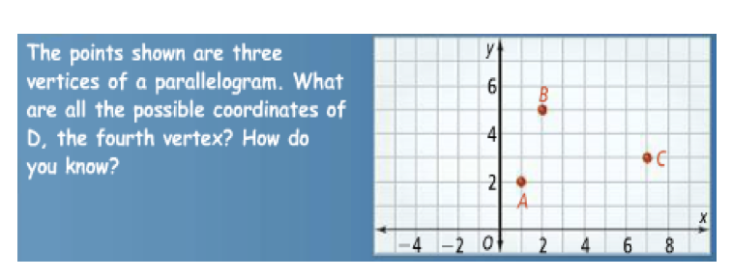

Find the coordinates of a DIFFERENT 4th point that would make ABCD a parallelogram. Prove that it is a parallelogram.

Find the coordinates of a DIFFERENT 4th point that would make ABCD a parallelogram. Prove that it is a parallelogram.

Extra Credit

+ 5 HW Points

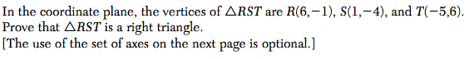

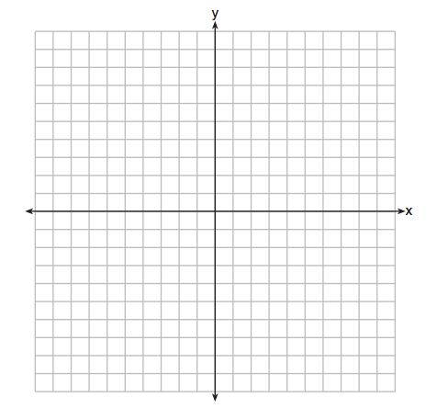

Screen%20Shot%202016-12-09%20at%207.32.47%20AM.png

Screen%20Shot%202016-12-09%20at%207.32.51%20AM.png

Extra Credit

+ 5 HW Points

